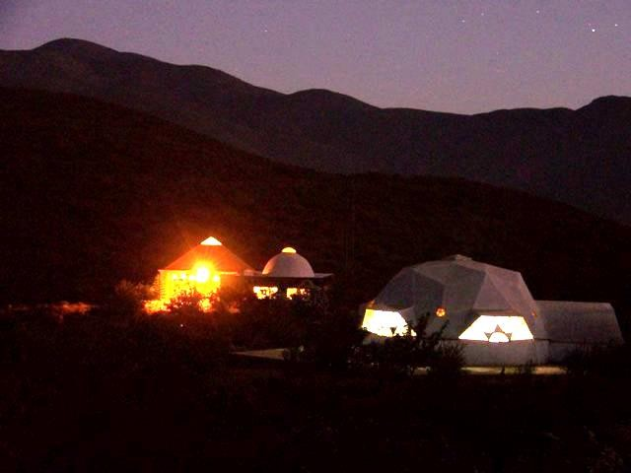
Letters 140
CHRISTMAS GREETINGS 2007
Dome and Getuls Chamber of the Las Californias Ashram, Ensenada, B.C., Mexico. Mexico.
Photo: Marcos Paulo González
We must be born again, in Spirit and in Truth! Let Santa Claus continue to laugh in the big stores full of gifts and bright lights - I said to the RedGFU Brotherhood in Puebla - We must work on ourselves so that the words of Master Jhesu are fulfilled in this New Age of Aquarius. We must assimilate the initiatory meaning of Christmas. The Son of Man has to be born again and carry his cross until he is redeemed as Christ the King. Take up your cross and follow me! - he said to us - and this cross is the one that limits our Being by centripetal spiral, by Love, to a form that constantly transforms itself in Space and to an existence that traps us in the cycles of time by centrifugal spiral, until our consciousness manages to rise and the Truth frees us. Where is the Truth? Here and now, in the Being of the One Being of our Being that gives life to the relativity of our human person.

In the days of Christmas there are events of cosmic order that push us towards the Christ without cross, in the same way that in the middle of the year, between June 22 and 24, we are trapped towards the Sacri-Ficio in the human, in the Northern Hemisphere, and towards the New Birth in the Southern Hemisphere. Paradoxes? More like dynamics by polarity, from the heart upwards and from the heart downwards. Superficialities or esoteric juggling? No. Simply Sacred and Real Initiation. Complicated? The MVHM said: the Truth is so simple that if I tell you it will not interest you. I have to complicate it with some mysteries so that they will decide to look for it.

In passing, it should be made clear that this elementary approach may be valid, if understood, for the Western Judeo-Christian mentality, but it is very dense for the Eastern mind, which seems to us Westerners to be very subjective. Well, it is the game of Tai, the Supreme, in the Yin and Yang. In the East the Yin is more pronounced and in the West the Yang. This does not mean that one is better than the other, but simply that they are complementary.

Let's get back to the point. As above, so below, is it really? Everything that happens above has repercussions below and everything that happens below leaves its mark above. Arrogance? Either we are or we are not. If we are, we are the synthesis of everything, if we are not, we are nothing. But to live being born and dying is something, at least, difficult, not to say painful in the style of Lord Siddhartha Gautama. Nothing is free in the macrocosmic Uni-Verse nor in the microcosmic Uni-Verse that we are, that is why we have dignity. So? We have to assume responsibility without standing on anyone's neck to believe that we are higher than him. Even the smallest creature is worthy of respect in its own place. Out of its place it can be dangerous and wretched. A triumph outside the place that corresponds to each one by order of conscience is suicide. It destroys what it is not capable of assimilating and destroys itself. It is self-deception.

In the days of Christmas we must sensitize ourselves with proper nutrition, exercises to balance the energies and hygiene so that everything flows smoothly. Meditation and Ceremonial are good; strident music and vibrant dances are bad if we are trying to assimilate the necessary strength to attempt a new birth. Eating ice cream between soup and stew may seem elegant, but it is disastrous for digestion. Otherwise, generosity is good when it is selfless. Excessive food and drink at midnight is not convenient, even if you substitute turkey for Ayacas Venezolanas and intoxicating drinks for tizanas.

The Qabbalah says that the Christ is Historical, Symbolic and Cosmic. In the historical it is an exceptional Human Being, in the symbolic it is the Way of Truth and Life that leads to the Father, and in the cosmic it is a force that is produced by polarization bet- ween the heart of our Galaxy and the heart of our planetary microcosm. This force reaches us all, but it is only received by those who have a clean Soul through service. For those of us whose Soul is occupied with frustrations, it brings us nothing.


Sat Arhat José Marcelli
December 25, 2007
www.redgfu.net/jmn

Original text in Spanish:
www.josemarcellinoli.com/2007/pdf/2007_cartas_140.pdf
Translation by: Marcos Paulo González Otero
email: gmarcosp@gmail.com
www.otero.pw
WhatsApp/Telegram: +52 686 119 4097
Version: 11092022-01
Please feel free to forward opinions and corrections.

