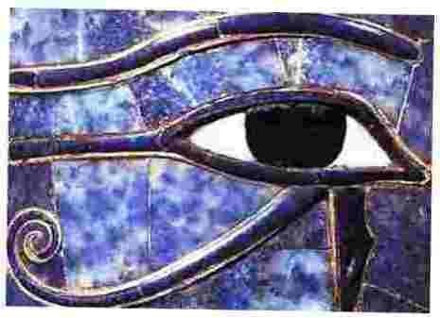
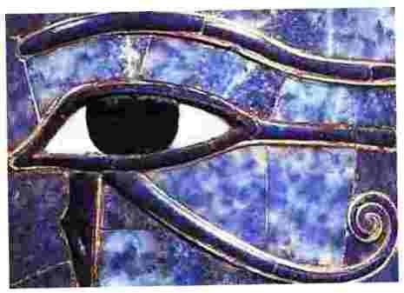

Letters 143

PAX... (...) what you tell me about Emotional Intelligence is true, it is a verification that emotions are based on instincts and are below mental activities, and that these are inferior to the power of the spirit, and of the Self, which manifests itself by centripetal and centrifugal spiral expansion and contraction. This is what is inferred from the First Seal of the Lion of the Tribe of Judah.

One must reflect on the Second Seal to realize the extent to which a human will can successfully act in reality within the Intelligent Order that maintains the Oneness of Diversity. These Seals are the Heritage of the MVHM. Thank you for your input to improve my Notes 941 - 950.

PAX... HR. We must study this new turn of events without giving hasty answers. Among the best we have achieved - as seen last July - our greatest success has been the consolidation of the Most Honorable Collegial Body. It is only this Honorable Body that has the authority to update the RedGFU Line if it deems it convenient. On the other hand, we must take advantage of any positive contribution to enrich with living facts the Line of Initiation that the MSMA and the MVHM pointed out to us for all Humanity, not only to consider the proposals of groups or persons who show desires of power or unethical protagonism.

PAX... M.R. Brother, the term "Master" is very much used among Craftsmen and Artists. I think it comes from the Middle Ages. It is nothing exceptional. Maybe that is why it is used with a certain freedom. For my part, I agree to give it a connotation of greater dignity among Initiates and I know that it will not be easy, because sympathizers often use it as children use it with their teachers. True Masters don't care. According to the VHM the title should be given to one who is recognized as Sat Arhat. The question that follows is how does one know who is Sat Arhat? The answer is obvious: by observing what a Sat Arhat says, does and lives positively, negatively or equitavely, without incomprehensible mysteries.

PAX...Q.H. The Natural Plan is to evolve. The MSMA came to point out the STYLE of evolution in the Aquarian Age with WISDOM. Wisdom is Faith and Conscious- ness united. Faith senses Truth and Consciousness gradually experiences it within the incalculable facets Truth takes on in Reality.
PAX...M.H.G. A Collegiate Body is an Agartha, a community that makes a great splendor by bringing together a multitude of small consciousnesses, of small lights, into one great consciousness, into one Great Light, which has greater scope than a single isolated consciousness has. This is possible because the marvelous phenomenon takes place in Reality. I realize that to put it this way may be almost offensive to those who believe that it is only a conclave of Masters of the highest level meeting in a Sacroteluric place inaccessible to the profane. I do not deny that this is so, but following the Initiatic teaching that says that as above so below, and that the slightest events above have repercussions below, and vice versa, I have seen symbolic acts and practical acts that fulfill the purpose of the Agartha Shanga, as, for example, and keeping the proportions, a Collegiate Body formed by Initiates.

PAX...Don (...) oddly enough it was only today that I set out to clean up my PC that I found this "black pearl". Well, maybe that was better. I don't know what this has to do with it Don (...) but I am sending you a copy. First of all, I thank you for your chivalry in sending it to me so that I would know about it. On the other hand, there is no error "that justifies another error" I don't want to make judgments or put qualifiers. The case is old, it is more than thirty years old and has been repeated with people who are somehow related to the GFU. I first heard about it when I arrived at Don's Institute (...) Then I heard about it two or three times from Yoga students and diners in vegetarian restaurants. This is the first time she alludes to me directly. I'm sorry, I really am, for her. That's all. If anyone would like more information, please inquire personally.

PAX...Thanks, Don (...) next time you want to immortalize me for a few minutes let me know in time to bring my hairstylist and manicurist. Sorry for the joke, but some movie stars look better than me on video and it's not fair. Anyway, I appreciate it.

PAX... I have not noticed that we do special events for women, but since you are a woman you must have sensed something. For that something I beg your pardon. Perhaps it is because in the last four thousand years, from the beginning of Aries to the end of Pisces, women have been relegated to a secondary role and we are trying to restore their equal participation, without losing their distinctive character, which is complementary and not equal to that of men.

Sat Arhat José Marcelli
January 5, 2008
www.redgfu.net/jmn

Original text in Spanish:
www.josemarcellinoli.com/2008/pdf/2008_cartas_143.pdf
Translation by: Marcos Paulo González Otero
email: gmarcosp@gmail.com
www.otero.pw
WhatsApp/Telegram: +52 686 119 4097
Version: 08072022-01
Please feel free to forward opinions and corrections.

