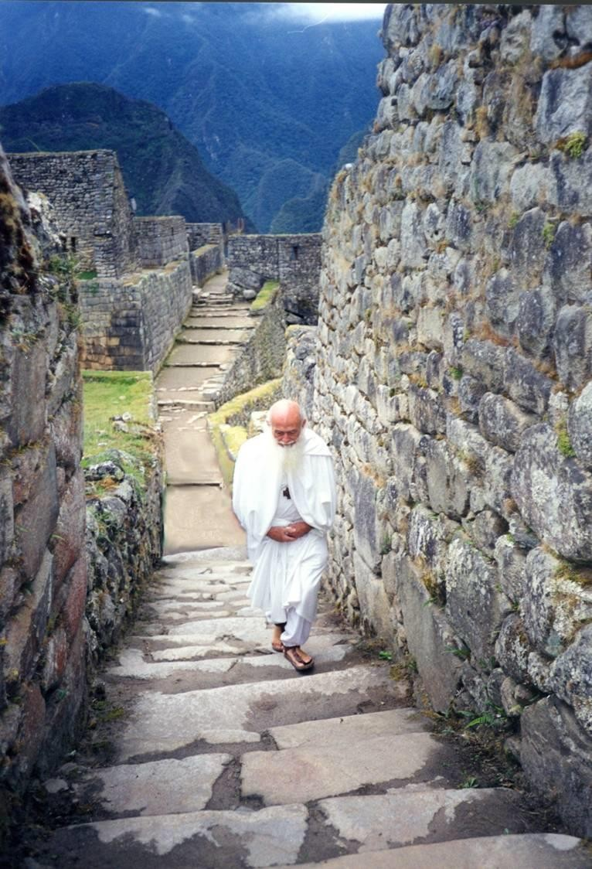
sun mooring
In Machu Picchu and Wayna Picchu, a ritual was practiced to bind the Sun, that is, to prevent the Sun from leaving without returning. This served to maintain the confidence of the people in their rulers and priests, but it was also practiced secretly to take advantage of the telluric energy of the place and turn it into a Sacred-Te lluric Center.

The secret aspect was only understood by the Real Initiates and was very far from the versions that have been popularized in literature in recent times, and also from the versions of the indigenous sorcerers and tourism promoters.

Master José Manuel Estrada, as a Disciple of Master de La Ferriere, took advantage of the tradition of the Sun's mooring to point out that the pole of spiritual development is now in America.

It's eleven past seven. It's time: Pax.

We three Masters crossed our arms over our chests, looked towards the top of a mountain where at that moment the Sun was beginning to rise and began the Ceremony of Tying the Sun, deeply concentrated and in silence. Then we circled around the Intihuantana, the place where the Sun is tied. I took an oil lamp and raised it towards the point where the Sun was located. The three of us asked permission, in a language of Being to Being, and I lit the fire.

Thus, we reaffirm the pact with the Sun that the Elder Brother made when he reactivated the Ceremonial Center of Machu Picchu.

We then descended to the Temple of the Three Windows to deliver the ritually activated fire to the Solar Hierarchy, while an Ahahua spontaneously blew a seashell toward the four cardinal points. I explained that the covenant with the Sacred Source of our Life had been renewed. A representative of the Hierarchy led the fire to the esplanade of the Gate of the Sun, Inti Punku, to be used as Sacred Fire in the Cosmic Ceremony that was officiated in the place before the Brotherhood of nineteen countries.

The Eternal Secret performed with an Andean Quena reverberated over the immense masses of the mountains, and it reached the bottom of the ravine where the Vilkamayo River meanders like a silver torrent embossed with feathers and was lost bouncing against the blue-green cliffs of the sierra that descends towards the Amazon. The telluric force of the Earth intensified when it pronounced: AUM TAT SAT! which ascended towards the Macrocosm and produced an opposing force that descended towards the Earth and polarized over the esplanade of Inti Punku. Its impact focused the consciousness of more than a thousand people who were witnessing the event, beyond the spatial and temporal revelations of the imagination. Those who thought they saw or felt so- mething identifiable were not yet ready to understand what was happening there. The majority of those present

were only self-aware and reaffirmed their consciousness of Being, without losing any of the grandeur of the spectacle that was offered to their senses. The reaffirmation of Being in Unity and of being in Diversity was emphasized with the Prayer in the open sky, with more than a thousand voices in chorus, with the Thirty-three Taus: Oh, Demiurge, listen to me, eternal demiurge, infinite demiurge, Unique demiurge, strength, jus- tice, love, help me...!

The cosmic game was dramatized on a small altar with seven symbols and a Master dressed in white, as a linking point between the blue-green and golden forces of the earth and the white and luminous sky where the Sun could be seen as a white disk, more luminous than the sky.
That day, June 22, 1998, after finishing the Cosmic Ceremony at Inti Punku, a young man - unknown to me - approached me and asked me, without preamble:

What did you do to tie the Sun?
I reaffirmed the pact we Solar Initiates have with him. How did you do it?
I simply communicated with Him from Being to Being, from sunrise to sunset, and everything was arranged.

The man looked confused. He tried to ask me something else but couldn't find the words. Perhaps he expected me to talk to him about magic formulas, spirits and complicated matters. He must have felt contempt or fear for my answer. We were speaking in two different languages.

He was following a tradition of innocence and poverty supported by the past and I was trying to assert myself in the Line of reality and consciousness, in the here and now of the present. It never occurred to me that he might be inferior to me, nor did I feel superior to him. We were simply working in different areas of the same field. He was working with water and I with fire, to put it in esoteric style which, translated into common language, means that he was working in the area of energy applied to emotions and feelings, visions and imagination, and I was working with fire, purification, light and intelligence. Even more simply: he was working in the dimensions of the human and Nature, and I was trying to move between the human and the Self, which is not strange at all, since we are Human Beings. Being, without the Human, is nothingness. The Human, without the Self, is a bad joke, where our destiny is only to be born, eat, grow, reproduce, and die, without knowing why.

The work with Water is no less important than the work with Fire. The Nahuatl called this double play of the forces of Life Atlchalchichinolli, burnt water, the purification of water, the phenomenon of the sea and the Sun, the play of the Being and the Human, depending on the interpretations of the Calmecac or the Calpulli, the two types of schools of Mexican antiquity dedicated to the training of sorcerers or Initiates. The balanced combination of natural things with the things created by man, reaffirms the dignity of human work and turns it into wealth when it is placed at the service of Nature. That is the work of the true Masters.

Wealth education prepares the individual to reaffirm the human for health, and makes health generate consciousness, to link the human with the sacred, with the Self, as life potential, and for the human to revert to the sacred as consciousness. This is called Circulation of Light.

Sun Bindings involve a great opportunity to reaffirm the human and the sacred consciously, and like all opportunities, it comes with responsibility. When the contact with an energy center is expanded, it is necessary to create an infrastructure to channel that potential. This is what happened with the telluric potential of the area known as Machu Picchu. Don Jose Manuel Estrada, the Master who reactivated that center in recent times, prepared his Disciples for several years with disciplines of nutrition, exercise, hygiene, service consciousness, meditation, and ritual. He did the same with the Chambers of High Initiation where this potential is handled in the celestial and terrestrial sense, that is, in positive and negative, like everything that concerns energy when it is used to convert it into Light.

After activating the Machu Picchu center, the Elder Brother found himself confronted with some of his fellow disciples, who went so far as to request an arrest warrant against him from the police of Cusco, Peru, and others who for more than thirty years tried to seize that force. Something similar happened with the first chamber of high initiation that the Master built and put into activity in the outskirts of Mexico City, which was destroyed without any respect for what it represented.
This is one of the problems generated by poverty, when it reacts against wealth and destroys its sources of energy, as ecologists proclaim today. But it is also the problem of wealth which, when it exaggerates its lust for power, destroys the resources that make it rich.

The Mooring of the Sun seems to be an idea of people not very experienced in cultural or scientific matters. It seems to try to take possession of something unconscionable, such as the Sun. In reality it is only a phrase for rural communities that live in poverty and are rich in natural goods, in relation to the goods produced by men. In the spheres of Royal Initiation, the mooring of the Sun is a work that is done to consciously link the energy center of our solar system with the energy centers of Human Beings. This conscious linkage brings wealth to those who are able to perform it. In ancient times priestly castes were formed that allied themselves with political and military powers and built grandiose ceremonial centers to make their wealth present to the people and govern them with the power of superior people.

In the background of the public apparatus, a few Solar Initiates kept, and keep, alive their conscious relationship with the Sun. The work of these men and women acts as an influence of balance and simplicity, of respect for life and courage to live it with joy. In reality they live richly, for their health and their consciousness, according to their knowledge, their needs and their customs. Sometimes, their attitude awakens envy among those who have power in their hands and live it with the poverty of their misgivings, or they impose it by force and create resent- ments that in the long run surpass their power and force them to use violence to keep it, until a new power is imposed and generates more poverty for all, destroying the accumulated effort and producing resentments and hatreds.

Hostility towards Solar Initiates acts like the clouds that hide the Sun and never manage to remove it from the firmament. Just as the Sun shines during the day and disappears to continue illuminating other regions of the world. Solar Initiates live their lives and die their deaths conscious of the natural rhythm of life. Their wealth consists in the acceptance of life and its natural richness, and in the use of their creative capacity, always ready to serve life and to serve themselves, just as the Sun does.

The Celestial Sun is present in the power of the Earthly Sun which remains centered in the sacral plexus of each Human Being. What makes a Human Being stand out or makes him mediocre, rich or poor, is the quality and quantity of his vital energy and his consciousness. This energy comes from the Sun and its presence in Human Beings depends on nutritional, geographical, genetic and cultural factors. All human acts, even the most subtle, consume energy. Instinctive acts need energy of higher density than intellectual acts. In an Indiana Jones movie, there is a passage where a strong and fierce man blocks the way to the hero of the film, snorting and showing off his vigor and his ability to handle scimitars, but his arrogance barely makes the hero of the film blink, who shoots him and makes him fall with a gesture of total bewilderment.

The subtle is more powerful than the dense. One is born with a certain natural amount of vital energy and that amount can be increased with self-discipline. The quality of this energy is achieved through breathing and trans- mutation techniques, but the transmutation of energy needs an axis, a center, which must be established by each individual. That center is the deep memory of the Self, the Self, the Self, the Being, or identity. It is from this identity that the individual can establish the relationship of his internal processes with the changing reality of his environment, and feel, act and think, according to the circumstances, in order to have his own base and make updated decisions.

The easy path is that of poverty and consists of postponing decisions or ignoring them so as not to assume responsibility for their effects. When decisions are made, there may be errors or successes, but within the process they can be compensated, seeking a favorable difference based on a middle ground, that is, with 51 percent in favor and 49 percent against, success is already certain. This percentage increases when the consciousness avoids extremism without neutralizing its dynamic effect. Life is a process driven by forces in polarity that seek their own perfection, adjusting their advances with the process of the Universe and generating experiences that outline currents with distinctive characteristics, until they become species projects and end up becoming individual projects that acquire self-awareness. It is consciousness that establishes the difference between wealth and poverty, for what is known and experienced can become wealth, and what is ignored or not understood is a decisive factor of poverty.

The Sun is the center of our planetary system. It is the closest manifestation, for us, of the sacred, of the divine, of the Self, of something that belongs to all of us and that transcends us all as human persons. We detect it as vital energy in the Sacral plexus and we know that it is maintained in us through a process that begins with photosynthesis, with the combination of sunlight and the salts and humidity of the earth, which are also dense solar matter, by means of nourishment. The ancestors of America sensed this and revered the translucent green stones, the Chalchihuites and the emeralds by association with photosynthesis and the color of chlorophyll. Quetzals, the green birds, were also associated with the elevation of life towards the divine.

Light is the subtlest element detected by our senses. Beyond the speed of light is the Sacred, secret, sacred, invisible, intangible and incomprehensible that we call Being, that which never began and will never end, and which is made visible, tangible and comprehensible, by contrast and comparison, with the human and Nature, by means of consciousness.

The sun is the arbiter of our destiny. Years ago, I arrived on a bright afternoon in Tulkán, a city in Ecuador bordering Colombia, at the foot of the Andes Mountains. Everything was bright and noble, as if immersed in a lake of translucent gold. The atmosphere seemed magical. A few minutes later the sun began to disappear behind the profile of the mountains. The clouds became puffs of gold and the steely color of the mountains changed to purple and finally became black. Then an icy shadow covered the earth, and I felt my body trapped in icy claws - Now I know why these people have traditionally been sun worshippers, I thought - I have experienced something similar in the Altiplano of Bolivia and in my wanderings and in the mountains of various countries. Also in the jungle, especially in the nights of Tikal, in Guatemala, where I felt sunk in a river of black ink, alive and turbulent, and heard stories of people who went mad in the darkness. On the other hand, I have also been told stories of people who stay forty days in total darkness to test the purity of their consciousness, or go into a deep, dark cavern to scream and vent their existential anguish, contacting the elemental spirits to feel comforted and safe because the Light is found within the deepest darkness.

The Sun Binding Tradition has a sense of high wisdom, for it ritually dramatizes the relationship between the Center of our Planetary System and the Center of our Body System, between the Celestial Sun and the Terrestrial Sun, which the Orientals call Kundalini and the Occidentals call Vital Energy, all for the benefit of those who seek their reason for being in the eternal and divine Being and find it reflected in the form and existence of the Human, in the reason for being of the Human Being. In the New Age of Aquarius is represented with the columns of Aquarius and Leo, and the prototypical figures of the MSMA and the MSHM.



